# PART 1: SOME BASIC OPERATIONS OF COMMON DATA STRUCTURES

## 1. ARRAY

**1.1. Add an element in any position in array.**

Complexity: T(n) = O(n) (add tail: T(n) = O(1))

**1.2. Remove an element in any position in array.**

Complexity: T(n) = O(n) (remove tail: T(n) = O(1))

**1.3. Change a value of element in array.**

Complexity: T(n) = O(n)

**1.4. Find min, max in array.**

Complexity: T(n) = O(n)

**1.5. Sort array.**

**+** Interchange sort:

Complexity: T(n) = O(n2)

+ Insertion sort

Complexity: T(n) = O(n2)

+ Bubule sort

Complexity: T(n) = O(n2)

+ Selection sort

Complexity: T(n) = O(n2)

+ Heap sort

Complexity: T(n) = O(nlogn)

+ Quick sort

Complexity: T(n) = O(nlogn)

+ Merge sort

Complexity: T(n) = O(nlogn)

+ Counting sort

Complexity: T(n) = O(n)

+ Bucket sort

Complexity: T(n) = O(n)

**1.7. Search in Array.**

**+** Sequential Search

Complexity: T(n) = O(n)

+ Binary Search

Complexity: T(n) = O(logn)

**2. LIST**

**2.1. Singly Linked List**

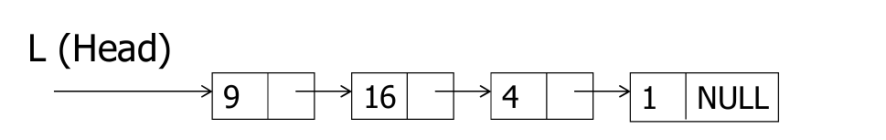

- ListSearch: Tìm kiếm một đối tượng có khóa k

T(n) = O(n)

- ListInsert: Chèn đối tượng có khóa k vào danh sách

+ Chèn vào đầu đầu: T(n) = O(1)

- ListDelete: Xóa đối tượng cuối danh sách: T(n) = O(1s)

- ListTraverse: T(n) = O(n)

3. STACK

4. QUEUE

5. TREE

6. HEAP

7. HASH TABLE

8. GRAPH

PART 2: SOME COMMON EXERCISES